BACKGROUNDER

WHERE WORLD LEADERS MEET AND UNFORGETTABLE EVENTS TAKE PLACE

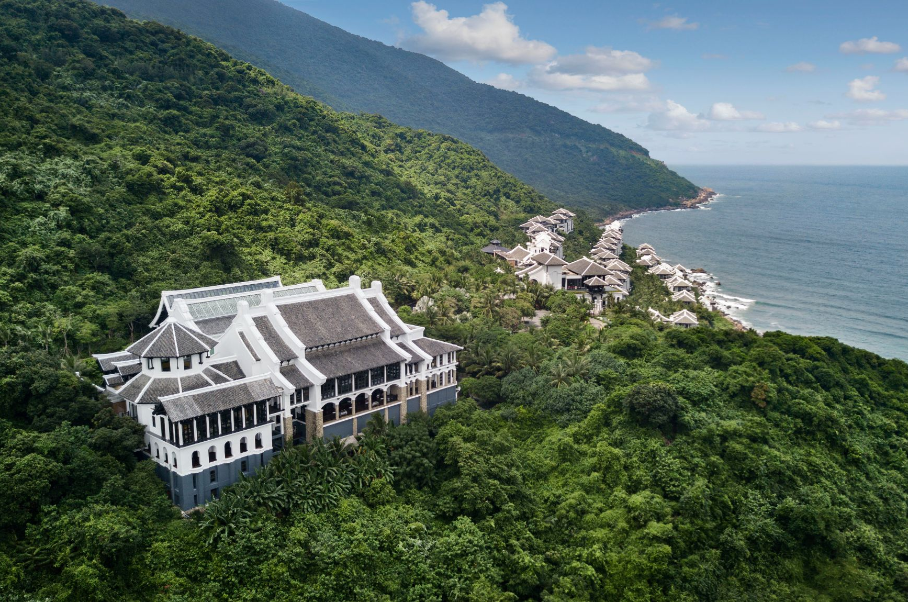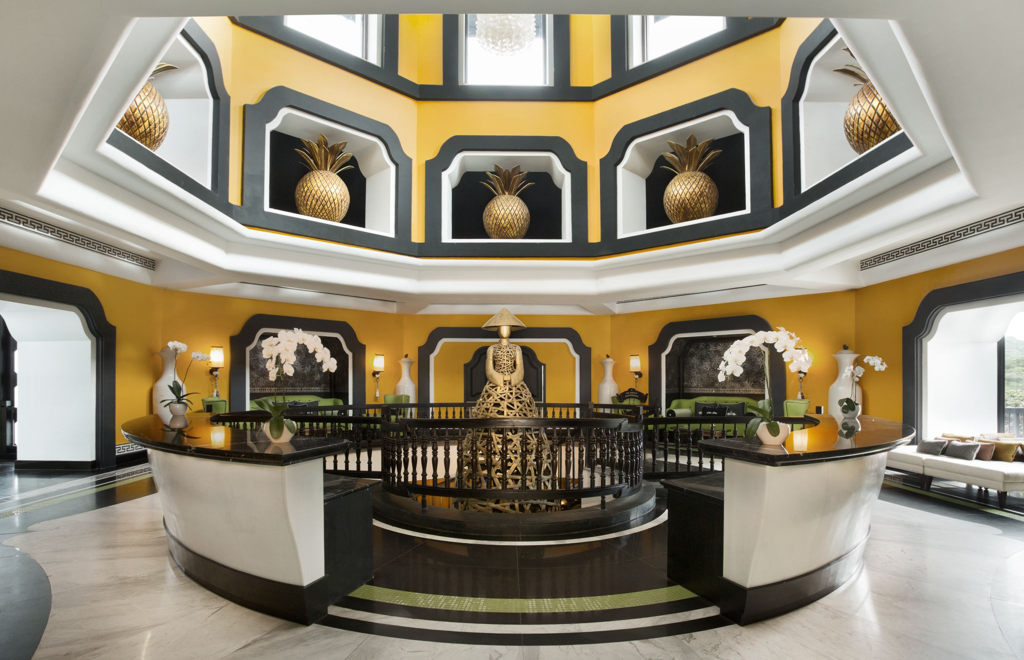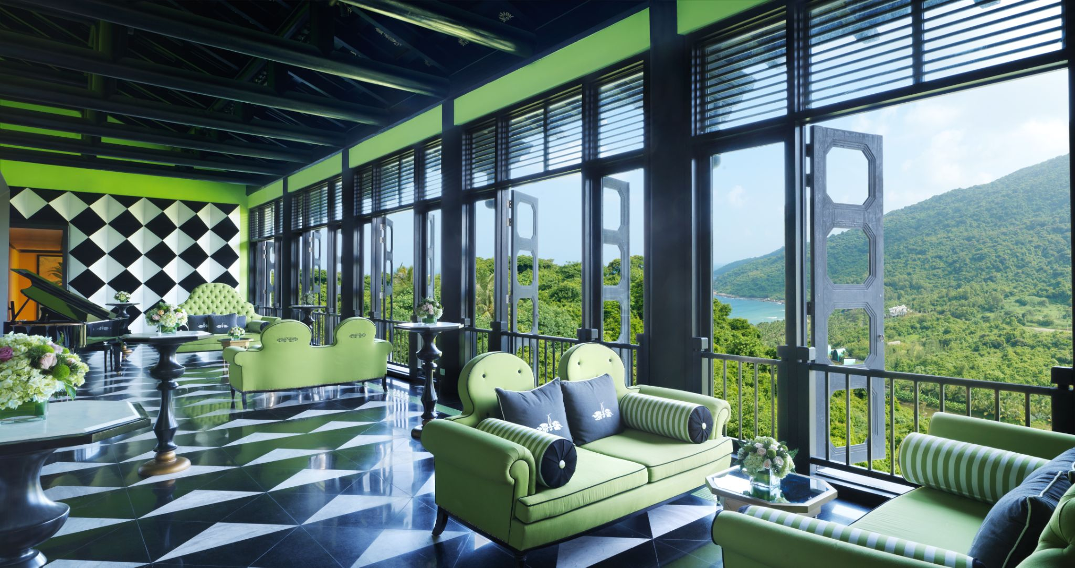
The Summit Conference Centre is one of the most remarkable meeting facilities in the world, and proudly
Hosted the APEC Summit meeting in 2017.

There’s long been a tendency for meeting and event spaces to be minimalist, free of unnecessary adornment and, dare we say it, verging on the bland. Perhaps the idea is that with a blank canvas, ideas will flow. But at the InterContinental Danang Sun Peninsula Resort, we believe the opposite. We believe that spaces filled with creativity, surprising design elements, awe-inspiring views and a touch of whimsy really get the creativity flowing. And that’s what guests can expect at The Summit, the resort’s meeting and events facility perched on top of the mountain with 180-degree views of the lush jungle, the surrounding mountains, and the lagoon below.

Designed by renowned architect Bill Bensley, the spaces reflect the resort’s signature black and white design aesthetic, representing yin and yang, with eye-catching lime green details. Bensley wanted to create a space filled with energy and life, where the surprising design would encourage people to engage with the space and each other, and revel in conversation. And that’s certainly the case here.

After being greeted by a towering statue of a Vietnamese woman rising through the centre of the circular courtyard hall, guests will discover that each of The Summit’s rooms has a different theme. The entry foyer is filled with tropical pineapple motifs and a burst of bright yellow. Traditional design touches including bamboo doors and ceiling beams inspired by Vietnamese temples offset the contemporary feel of the Great Hall pre-function area, which is a gallery-like space with dazzling black and white walls and floors (it’s called the “zebra crossing” by the staff).

The hidden Cheeky Monkey event space, inspired by the fictional and adventurous monkey Charles, features banana motifs, intimate spaces for dining, drinking or secretive conversations, and even a private cinema. And the lofty white Reception Hall is filled with light, creating a space where inspiration and imagination soars.

Those who host meetings and events at The Summit will be in good company – the first event to be held here was the 2017 APEC Summit when world leaders from 20 countries came to the resort for high-power meetings. This event is commemorated in the APEC Garden, a contemplative space with a series of sculptures representing iconic landmarks from each of the participating countries. Take a journey through the garden and you’ll discover the stepped pyramid from Chichén Itzá in Mexico, Malaysia’s Petronus Towers, a Moai from Chile’s Easter Island, and St Basil’s Cathedral from Red Square in Moscow, amongst many others.

And service at The Summit is also taken to another level. Our on-site experts can help you choose local specialties to add to your coffee breaks, suggest additional outdoor venue options throughout the resort to help you and your guests make the most out of the beautiful setting, and even show you the best photo spots to guarantee that your event whether global summit, meeting or party, will be commemorated in the best way possible.

Media Contact
Giang Ha, Assistant Director of Marketing
giang.ha@ihg.com
+84 974 349 463

